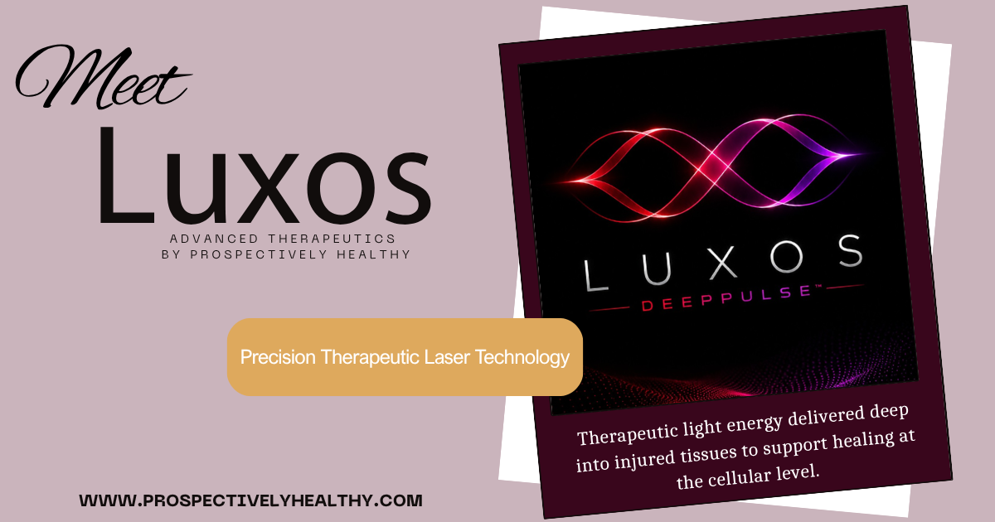

What is LUXOS™ DeepPulse™?
LUXOS™ DeepPulse™ is an advanced Class IV therapeutic laser that delivers concentrated light energy deep into injured tissues to stimulate cellular repair, improve circulation, reduce inflammation, and relieve pain. Using dual therapeutic wavelengths, LUXOS™ supports the body's natural healing processes without surgery or injections.

Dual-Wavelength Technology
LUXOS™ DeepPulse™ combines 980 nm and 1024 nm therapeutic laser wavelengths into a single treatment. Each wavelength interacts with tissue differently, allowing your provider to treat a broader range of structures while supporting circulation, reducing inflammation, and promoting tissue repair.

Deep Tissue Penetration
Unlike lower-powered lasers that primarily affect superficial tissues, LUXOS™ delivers therapeutic light energy deeper into muscles, tendons, ligaments, fascia, and joints. This allows treatment of both surface and deeper structures without needles or surgery.

Higher Therapeutic Power
As a Class IV therapeutic laser, LUXOS™ delivers significantly more energy than many lower-powered laser systems. Higher power allows an effective therapeutic dose to reach injured tissues in a shorter period of time, resulting in efficient treatment sessions while maintaining patient comfort.

Precise Energy Delivery
LUXOS™ is designed to deliver controlled light energy directly to the targeted treatment area. By adjusting treatment parameters for each condition, your provider can customize therapy based on the tissue being treated, the depth of the injury, and your individual treatment goals.

Research-Supported Technology

Class IV laser therapy, also known as photobiomodulation, has been extensively studied for its ability to reduce pain, improve circulation, decrease inflammation, and accelerate tissue healing. Research supports its use for many musculoskeletal conditions, including tendon injuries, arthritis, muscle strains, nerve irritation, postoperative recovery, and chronic pain.

Versatile Across Many Conditions

LUXOS™ can be used throughout the body to treat both acute and chronic conditions involving muscles, tendons, ligaments, joints, fascia, and peripheral nerves. Its versatility makes it an excellent option for patients seeking a non-invasive treatment that can be incorporated into a comprehensive rehabilitation plan.

Why We Chose LUXOS™ DeepPulse™
Not all therapeutic lasers are created equal. At Prospectively Healthy, we carefully evaluated available laser technologies before selecting LUXOS™ DeepPulse™. We chose a high-power Class IV system because it combines dual therapeutic wavelengths, deep tissue penetration, and research-supported photobiomodulation into a comfortable, non-invasive treatment designed to support your body's natural healing processes.
Our commitment has always been to invest in technologies backed by science while providing patients with safe, effective, and individualized care. LUXOS™ allows us to deliver advanced laser therapy as part of a comprehensive treatment plan focused on helping you move better, heal naturally, and return to the activities you enjoy.

Why Choose Prospectively Healthy?
At Prospectively Healthy, we believe healing is rarely achieved through a single treatment alone. While LUXOS™ DeepPulse™ is a powerful therapeutic tool, it is most effective when combined with a thoughtful diagnosis, individualized treatment planning, and a comprehensive approach to health.
Every patient receives a personalized care plan that may incorporate Class IV laser therapy alongside chiropractic care, focused shockwave therapy, regenerative medicine, therapeutic exercise, nutrition, and other supportive therapies when appropriate. Our goal is not simply to reduce pain—but to restore function, promote healing, and help you return to the activities you enjoy.

How Does It Work?
Rather than simply masking symptoms, LUXOS™ DeepPulse™ uses a process known as photobiomodulation, where therapeutic light energy is absorbed by cells to stimulate the body's natural healing response. As the light reaches injured tissues, it supports cellular energy production, improves circulation, and activates biological processes involved in tissue repair and recovery.
Research has shown Class IV laser therapy may:
- Increase cellular energy (ATP) production, providing cells with the energy needed for repair and regeneration.
- Improve blood flow and circulation, helping deliver oxygen and nutrients to injured tissues.
- Support lymphatic drainage, reducing swelling and promoting removal of cellular waste products.
- Help reduce inflammation by supporting the body's normal healing response.
- Promote collagen production and tissue remodeling within muscles, tendons, ligaments, and fascia.
- Support nerve healing and reduce pain by influencing normal cellular signaling and tissue health.
Unlike treatments that simply provide temporary pain relief, LUXOS™ DeepPulse™ is designed to address the underlying cellular processes involved in healing, helping your body recover naturally while improving pain, function, and mobility.

Conditions Commonly Treated
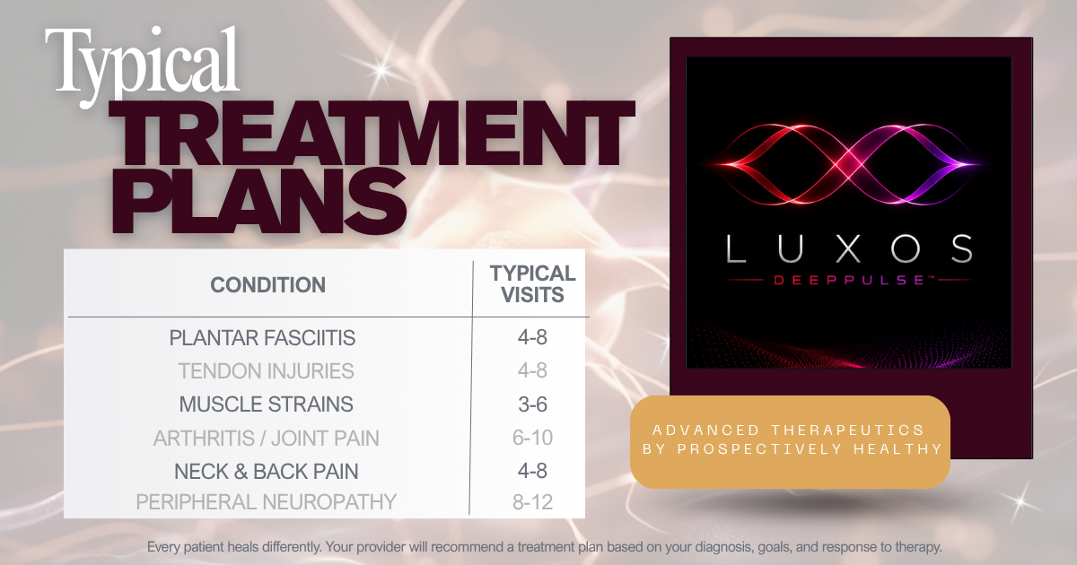
LUXOS™ DeepPulse™ may be recommended for a variety of acute and chronic musculoskeletal conditions involving muscles, tendons, ligaments, joints, fascia, peripheral nerves, and other soft tissues. Your provider will determine whether Class IV laser therapy is appropriate based on your diagnosis, medical history, physical examination, and treatment goals.

Common conditions include:
Foot & Ankle
- Plantar fasciitis
- Achilles tendinopathy
- Ankle sprains
- Posterior tibial tendon dysfunction
- Peripheral neuropathy (selected patients)

Knee
- Knee osteoarthritis
- Patellar tendinopathy (Jumper's Knee)
- Quadriceps tendinopathy
- MCL/LCL sprains
- Meniscal irritation (supportive care)

Hip & Pelvis
- Greater trochanteric pain syndrome
- Gluteal tendinopathy
- Hip osteoarthritis
- Proximal hamstring tendinopathy
- Piriformis syndrome

Shoulder
- Rotator cuff tendinopathy
- Shoulder impingement
- Biceps tendinopathy
- Frozen shoulder (adhesive capsulitis)
- Calcific shoulder tendinitis

Elbow & Wrist
- Tennis elbow (lateral epicondylitis)
- Golfer's elbow (medial epicondylitis)
- Wrist tendonitis
- De Quervain's tenosynovitis
- Carpal tunnel syndrome (selected patients)

Spine & Neck
- Mechanical neck pain
- Mechanical low back pain
- Muscle strain and spasm
- Sacroiliac joint dysfunction (supportive care)
- Facet-related pain

Muscles & Soft Tissue
- Muscle strains
- Trigger points
- Myofascial pain
- Ligament sprains
- Sports injuries
- Post-operative tissue healing

Nerve Conditions
- Peripheral neuropathy
- Neural irritation
- Post-surgical nerve recovery (selected patients)

What Should I Expect?
Unlike treatments that simply mask pain, LUXOS™ DeepPulse™ is designed to support your body's natural healing processes at the cellular level. Many patients experience a gentle warming sensation during treatment, and sessions are typically comfortable and relaxing.
Patients may experience:
- Mild warmth during treatment
- Temporary improvement in pain or mobility following treatment
- Gradual reduction in pain and inflammation over several treatments
- Continued healing and tissue recovery between visits
- Progressive improvement in function as damaged tissues heal
For the best possible outcome, it is important to follow your provider's recommendations regarding activity modification, stretching, strengthening, home exercises, nutrition, hydration, and any additional therapies that may be recommended as part of your individualized treatment plan.

Risks & Possible Side Effects
LUXOS™ DeepPulse™ is generally well tolerated, and most side effects are mild, temporary, and resolve without intervention.
Common side effects may include:
- A gentle warming sensation during treatment
- Temporary redness of the skin
- Mild soreness or tenderness
- Temporary increase in symptoms as healing begins
- Mild fatigue following treatment (occasionally reported)
Although uncommon, more significant complications may occur, including skin irritation or superficial burns if treatment protocols are not followed, temporary aggravation of symptoms, or eye injury if appropriate protective eyewear is not worn. Your provider follows established safety protocols and will determine the appropriate treatment settings based on your diagnosis, medical history, and individual needs.

Who May Not Be a Candidate?
Class IV laser therapy may not be appropriate for everyone. Treatment may be delayed, modified, or avoided in certain situations, including:
- Pregnancy (avoid treatment directly over the abdomen or low back)
- Known or suspected cancer within the planned treatment area
- Direct treatment over the eyes
- Photosensitivity or medications that increase sensitivity to light
- Active hemorrhage or bleeding disorders
- Active infection within the treatment area
- Certain implanted electronic devices or situations requiring manufacturer-specific precautions
- Other medical conditions that, in your provider's clinical judgment, may make treatment inappropriate
Your provider will carefully review your medical history, medications, and current condition to determine whether Class IV laser therapy is a safe and appropriate treatment option for you.

Maximize Your Results
For the best possible outcome, we encourage patients to support their body's natural healing process by:
- Eating a nutrient-dense, protein-rich diet
- Staying well hydrated
- Prioritizing quality sleep and recovery
- Following your prescribed home exercise program
- Using provider-recommended nutritional supplements when appropriate
Your provider may recommend additional nutritional support based on your individual needs and treatment goals.

Pricing
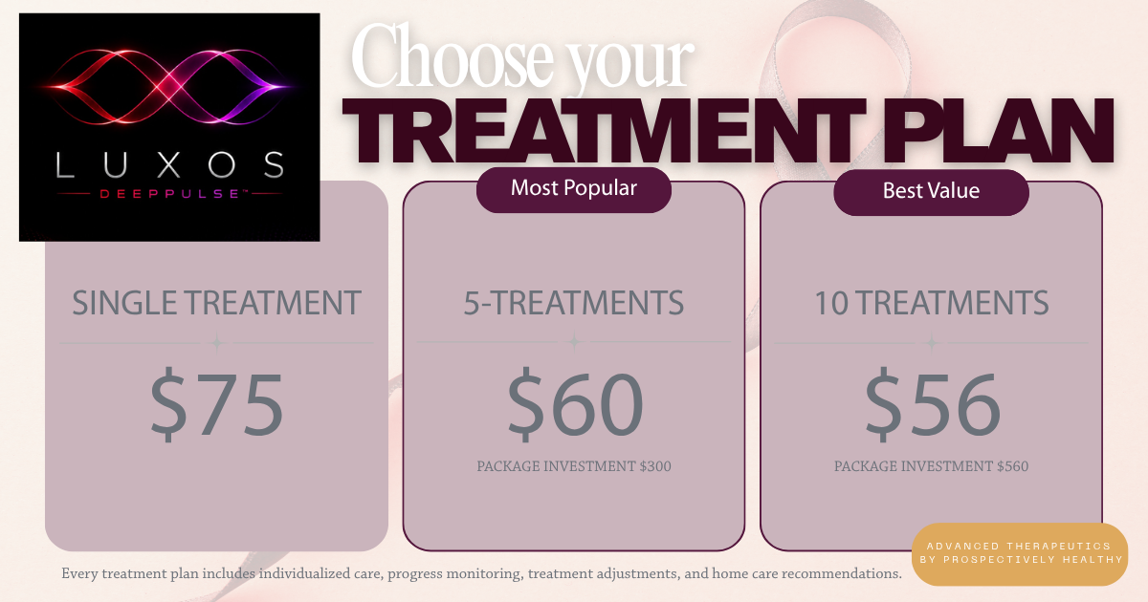
Choose the treatment plan that best fits your recovery goals. Treatment packages provide the greatest value for patients who are committed to achieving lasting results. Patients actively participating in another treatment plan at Prospectively Healthy receive a 15% courtesy discount on individual LUXOS™ DeepPulse™ treatment sessions. Your provider will help determine the option that best supports your diagnosis, goals, and expected course of care.

Healing Doesn't End Here

Ask your provider about nutrition, movement, supplements, and additional therapies that may complement your LUXOS™ treatment plan.

Frequently Asked Questions

How is LUXOS™ DeepPulse™ different from other therapeutic lasers?
LUXOS™ DeepPulse™ is a high-power Class IV therapeutic laser that delivers light energy deep into injured tissues. Its dual wavelengths and advanced photobiomodulation technology help support healing, reduce pain, and improve function while treating muscles, tendons, ligaments, joints, and other soft tissues.

What is Class IV Laser Therapy?
LUXOS™ DeepPulse™ uses therapeutic light energy to stimulate your body's natural healing processes. By improving cellular energy production, circulation, and tissue repair, Class IV laser therapy helps reduce pain, decrease inflammation, and support healing without surgery or injections.

What conditions can it treat?
LUXOS™ DeepPulse™ is commonly used to treat tendon and ligament injuries, muscle strains, arthritis, plantar fasciitis, neck and back pain, sports injuries, peripheral neuropathy, and many other musculoskeletal conditions. Your provider will determine whether Class IV laser therapy is appropriate for your diagnosis.

How long does a treatment take?
Most appointments last 20–30 minutes, including evaluation, treatment, and aftercare instructions. Laser treatment time varies by the size and number of areas being treated.

Does the treatment hurt?
Most patients find LUXOS™ DeepPulse™ treatments comfortable and relaxing. You may experience a gentle warming sensation over the treatment area, but the procedure is generally well tolerated and non-invasive.

Will I feel the warmth from the treatment?
Yes. Most patients notice a pleasant feeling of warmth during treatment. Your provider monitors your comfort and adjusts settings as needed.

Why do I wear protective glasses?
Protective eyewear is required during every Class IV laser treatment to shield your eyes from the therapeutic laser light. Both you and your provider will wear safety glasses throughout the procedure.

Does the laser touch my skin?
Yes. The laser handpiece is typically placed directly against or just above the skin while moving over the treatment area to safely deliver therapeutic light energy.

Can I purchase a single treatment?
Absolutely. Individual treatments are available for patients who wish to try LUXOS™ DeepPulse™ or require only occasional care.

Do I have to purchase a package?
No. Packages are optional but provide the best overall value for patients who are expected to benefit from multiple treatments.

I’m already a patient. Do I receive a discount?
Yes! Patients actively participating in another treatment plan at Prospectively Healthy receive 15% off individual LUXOS™ DeepPulse™ treatment sessions.

Can I use my HSA or FSA?
In many cases, yes. We recommend checking with your HSA/FSA administrator to confirm your specific plan’s eligibility requirements.

What should I expect afterward?
Most patients return to normal activities immediately. Some notice improvement after a single session, while others improve gradually over several treatments. Mild warmth or temporary soreness may occur but typically resolves quickly.

How many treatments will I need?
Treatment recommendations vary depending on your diagnosis, symptom duration, and treatment goals. Most patients benefit from 3–6 treatments, typically scheduled about one week apart, although some conditions may require additional visits. Your provider will recommend an individualized treatment plan.

Will I feel better immediately?
Some patients notice improvement after their first treatment, while others improve more gradually over several sessions. Healing continues between visits as your body responds to therapy.

Can I exercise afterward?
In most cases, yes. Your provider may recommend temporarily modifying strenuous activity depending on your condition and stage of healing. Walking and normal daily activities are typically encouraged unless otherwise directed.

Can I combine VECTRA™ with other services at Prospectively Healthy?
Absolutely. LUXOS™ DeepPulse™ is often paired with other therapies to support healing and improve outcomes. Depending on your diagnosis and treatment goals, your provider may recommend combining Class IV laser therapy with chiropractic care, VECTRA™ Focuswave™, regenerative medicine, rehabilitation exercises, nutritional support, or other therapies offered at Prospectively Healthy.
Your provider will recommend the most appropriate combination of therapies and treatment sequence based on your individual condition and recovery goals.

We're here to help. If you have additional questions about LUXOS™ DeepPulse™, your treatment plan, or whether focused shockwave therapy is right for you, please contact our office. Our team is happy to help guide you through the next steps of your recovery.

