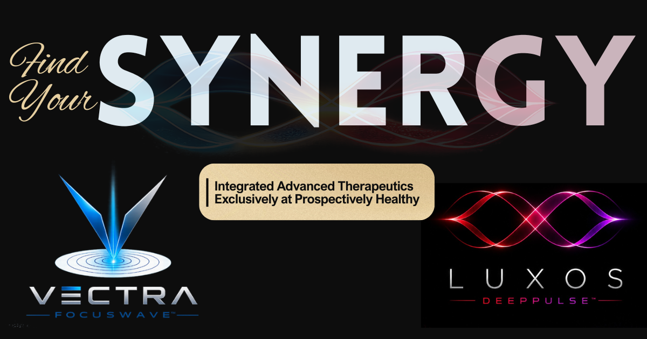

Meet SYNERGY™

Integrated Advanced Therapeutics
SYNERGY™ combines VECTRA™ Focuswave™ and LUXOS™ DeepPulse™ into a single treatment designed to support healing through complementary biological pathways. By combining focused acoustic energy with advanced therapeutic laser technology, SYNERGY™ addresses both tissue regeneration and cellular recovery in one comprehensive treatment session.

What is SYNERGY™?

Rather than relying on a single technology, SYNERGY™ combines two evidence-informed therapies that work through different—but complementary—mechanisms.

VECTRA™ Focuswave™ uses precisely focused acoustic energy to stimulate tissue regeneration, remodeling, and repair.

LUXOS™ DeepPulse™ uses therapeutic light energy to improve cellular metabolism, circulation, and recovery.

Together, these therapies create a comprehensive approach to supporting your body's natural healing processes.

Why We Choose to Combine Them
At Prospectively Healthy, we believe the best outcomes often come from combining evidence-based therapies that support healing through different biological pathways.
Focused shockwave therapy stimulates tissue regeneration through mechanical signaling, while Class IV laser therapy enhances cellular energy production, circulation, and recovery. By using these technologies together, we can address multiple aspects of the healing process during the same treatment plan.
Every patient is unique, and not every condition requires both therapies. Your provider will determine whether a combined treatment approach is appropriate based on your diagnosis, examination, and recovery goals.

Why Choose Prospectively Healthy?
At Prospectively Healthy, we believe the best outcomes rarely come from a single treatment or technology alone. While SYNERGY™ combines two advanced regenerative therapies, its greatest strength lies in being part of a comprehensive, individualized treatment plan tailored to your unique diagnosis, goals, and stage of healing.
Every patient receives a thorough evaluation, and your provider will determine whether combining focused shockwave therapy with Class IV laser therapy is appropriate for your condition. When indicated, SYNERGY™ may also be integrated with chiropractic care, regenerative medicine, rehabilitation exercises, nutritional support, and other evidence-informed therapies to optimize healing, restore function, and help you return to the activities you enjoy.

How Do They Work Together?
Healing is a complex process involving many different biological systems. Rather than relying on a single technology, SYNERGY™ combines two evidence-informed therapies that support recovery through complementary mechanisms.
VECTRA™ Focuswave™ stimulates the body's regenerative response by encouraging tissue remodeling, collagen production, and improved blood flow. LUXOS™ DeepPulse™ supports healing at the cellular level by increasing energy production, improving circulation, and creating an environment that promotes tissue repair.
Together, these therapies work to address both the underlying tissue injury and the cellular processes that support healing, providing a comprehensive approach to recovery that may enhance comfort, improve function, and promote lasting results.

Conditions Commonly Treated

SYNERGY™ may be recommended for patients who are expected to benefit from the combined effects of focused shockwave therapy and Class IV laser therapy. By addressing both tissue regeneration and cellular recovery, a combined treatment approach may be appropriate for a variety of acute and chronic musculoskeletal conditions.

Common conditions include:
- Plantar fasciitis
- Achilles tendinopathy
- Tennis & golfer's elbow
- Rotator cuff tendinopathy
- Patellar tendinopathy
- Greater trochanteric pain syndrome
- Muscle strains and ligament sprains
- Arthritis and chronic joint pain
- Sports injuries
- Chronic neck and back pain
- Post-operative rehabilitation (when appropriate)
Not every condition requires both therapies. Your provider will determine whether SYNERGY™ is appropriate based on your diagnosis, examination findings, medical history, and treatment goals.
For more detailed information about each therapy and the conditions it treats, please refer to the VECTRA™ Focuswave™ and LUXOS™ DeepPulse™ Patient Guides.

What Should I Expect?
SYNERGY™ combines two complementary therapies in a single treatment session. During your appointment, your provider will first perform VECTRA™ Focuswave™ therapy, followed by LUXOS™ DeepPulse™ laser therapy. While each treatment works differently, they are designed to support your body's natural healing processes together.
Some patients notice improved comfort or mobility immediately following treatment, while others experience more gradual improvement as tissue healing continues over the following days and weeks. It is also common to experience temporary soreness after treatment—particularly in chronically injured tissues—as your body responds to the healing process.
For the best possible outcome, it is important to follow your provider's recommendations regarding activity modification, rehabilitation exercises, nutrition, hydration, and any additional therapies that may be included as part of your individualized treatment plan.

Risks & Possible Side Effects
SYNERGY™ combines two well-established, non-invasive therapies that are generally well tolerated when used appropriately. Because this treatment includes both focused shockwave therapy and Class IV laser therapy, patients may experience the side effects associated with either treatment.
Common temporary side effects may include:
- Mild soreness or tenderness
- Temporary redness or warmth
- Bruising or swelling
- Temporary increase in symptoms as healing begins
- Mild fatigue following treatment
These effects are typically short-lived and resolve within several days. Your provider will discuss what you can expect based on your diagnosis and treatment plan.
For a complete discussion of risks, contraindications, and potential side effects specific to each therapy, please refer to the individual VECTRA™ Focuswave™ and LUXOS™ DeepPulse™ Patient Guides.

Who May Not Be a Candidate?
Because SYNERGY™ combines both focused shockwave therapy and Class IV laser therapy, you must be an appropriate candidate for both treatments. If either therapy is contraindicated based on your medical history, current medications, treatment area, or diagnosis, your provider may recommend using only one therapy or selecting an alternative treatment approach.
Your provider will carefully review your medical history, current condition, and treatment goals to determine whether SYNERGY™ is safe and appropriate for you.
For detailed information regarding contraindications and precautions specific to each therapy, please refer to the individual VECTRA™ Focuswave™ and LUXOS™ DeepPulse™ Patient Guides.

Maximize Your Results
Like every treatment plan at Prospectively Healthy, SYNERGY™ works best when paired with healthy lifestyle habits that support your body's natural healing processes. Staying well hydrated, eating a nutrient-dense diet with adequate protein, prioritizing quality sleep, managing stress, and following your provider's recommendations for activity modification and rehabilitation exercises all play an important role in recovery. When appropriate, your provider may also recommend nutritional supplements or other supportive therapies to help optimize healing. Because focused shockwave therapy relies on your body's natural inflammatory healing response, we recommend avoiding non-steroidal anti-inflammatory medications (NSAIDs), such as ibuprofen (Advil®, Motrin®) and naproxen (Aleve®), unless otherwise directed by your healthcare provider.

Pricing
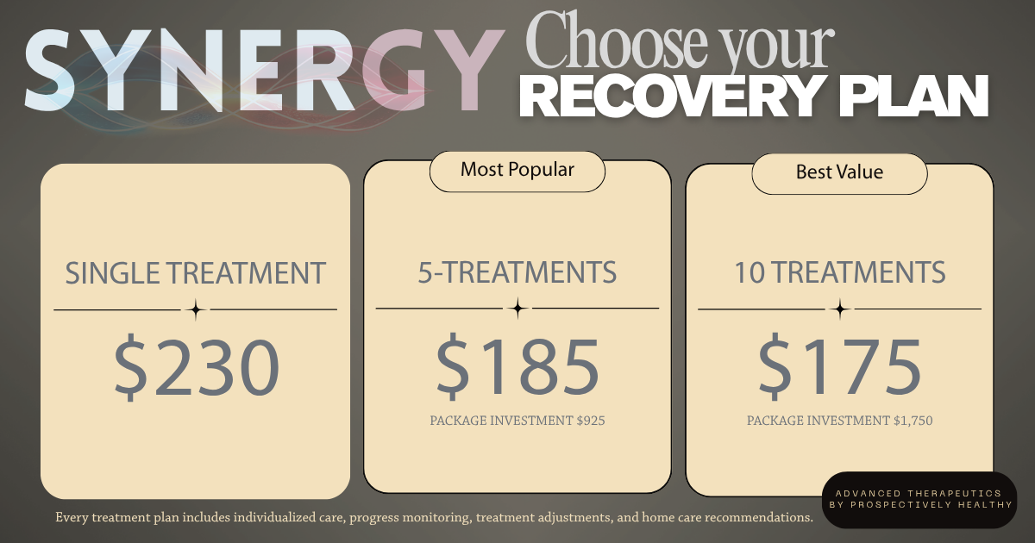
SYNERGY™ combines the regenerative effects of VECTRA™ Focuswave™ with the cellular support of LUXOS™ DeepPulse™ to maximize each treatment session. By delivering focused shockwave therapy immediately followed by Class IV laser therapy, both technologies work together to support tissue repair, improve circulation, reduce inflammation, and optimize your body's natural healing response. Treatment packages provide the greatest value for patients who are expected to benefit from this comprehensive approach over multiple visits. Patients actively participating in another treatment plan at Prospectively Healthy receive a 15% courtesy discount on individual treatment sessions. Your provider will recommend the treatment plan best suited to your diagnosis, goals, and expected course of care.

Healing Doesn't End Here

Ask your provider about nutrition, movement, supplements, and additional therapies that may complement your SYNERGY™ treatment plan.

Frequently Asked Questions

Can I purchase a single SYNERGY™ treatment?
Absolutely. Individual treatments are available for patients who wish to experience the combined benefits of VECTRA™ Focuswave™ and LUXOS™ DeepPulse™ or who require occasional care.

Do I have to purchase a treatment plan?
No. Treatment plans are optional but provide the greatest value for patients who are expected to benefit from multiple combined treatments over time.

I'm already a patient. Do I receive a discount?
Yes! Patients actively participating in another treatment plan at Prospectively Healthy receive a 15% courtesy discount on individual SYNERGY™ treatment sessions.

Can I use my HSA or FSA?
In many cases, yes. We recommend checking with your HSA or FSA administrator to confirm your plan's eligibility requirements.

How is SYNERGY™ different from receiving VECTRA™ or LUXOS™ alone?
SYNERGY™ combines both technologies into a single treatment session. While VECTRA™ stimulates tissue regeneration through focused acoustic energy, LUXOS™ supports healing at the cellular level through therapeutic laser technology. Together, they provide a comprehensive treatment approach designed to optimize recovery by supporting multiple stages of the healing process.

Where can I learn more about each therapy?
For detailed information about treatment expectations, risks, side effects, aftercare, and frequently asked questions specific to each technology, please refer to the individual VECTRA™ Focuswave™ Patient Guide and LUXOS™ DeepPulse™ Patient Guide, available through the patient portal or from our office.

We're here to help. If you have additional questions about SYNERGY™, your treatment plan, or whether focused shockwave therapy is right for you, please contact our office. Our team is happy to help guide you through the next steps of your recovery.

