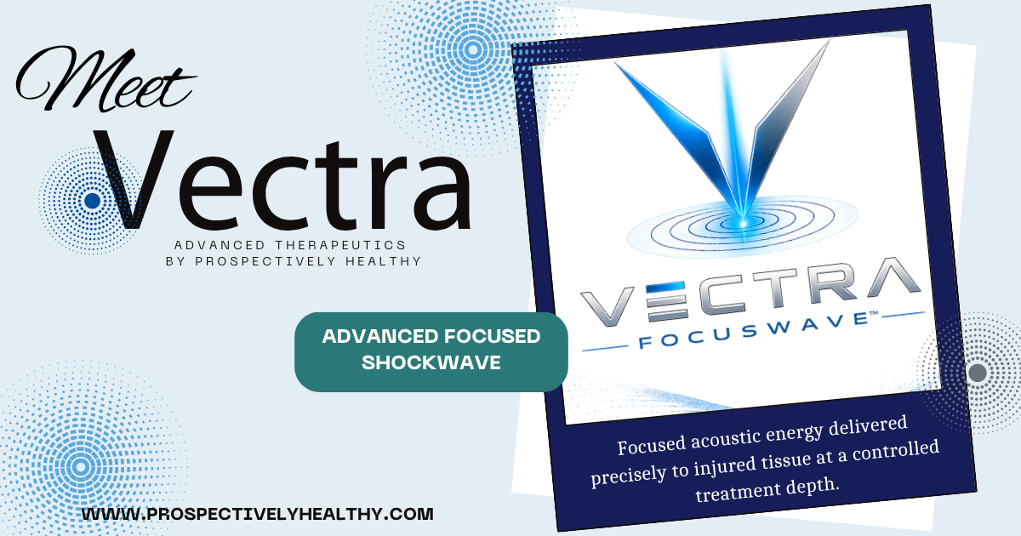

What is VECTRA™ Focuswave™?
VECTRA™ Focuswave™ is an advanced form of Focused Shockwave Therapy (Extracorporeal Shockwave Therapy, or ESWT). Unlike traditional radial pressure wave devices, VECTRA™ delivers precisely focused acoustic energy directly to the injured tissue at a controlled depth beneath the skin. This targeted approach is designed to stimulate the body's natural healing processes while minimizing unnecessary energy to surrounding healthy tissues.

Precise Depth Control
Focused shockwave allows your provider to target the injured tissue at its actual depth, whether near the surface or several centimeters below the skin. This precision helps deliver treatment where it is needed most while minimizing unnecessary treatment of surrounding tissues.

Higher Therapeutic Energy
Focused shockwave delivers significantly greater energy than radial pressure wave therapy, allowing treatment of chronic tendon injuries, ligament disorders, plantar fasciitis, bone-related conditions, and other musculoskeletal problems that often require deeper, more concentrated therapy.

Designed for Deep Structures
Many painful conditions originate well beneath the skin's surface. Focused shockwave can effectively target structures such as hip tendons, hamstring origins, deep muscle trigger points, ligaments, fascia, and selected bone conditions that may be difficult to reach with more superficial treatment technologies.

Research-Supported Technology

Focused shockwave therapy is supported by decades of clinical research for a variety of orthopedic and musculoskeletal conditions, including plantar fasciitis, Achilles tendinopathy, tennis elbow, calcific shoulder tendinitis, greater trochanteric pain syndrome, delayed bone healing, and other chronic soft tissue injuries.

Why We Chose Focused Shockwave
At Prospectively Healthy, we carefully evaluated available shockwave technologies before selecting VECTRA™ Focuswave™. We chose true focused shockwave because of its ability to precisely target injured tissues at depth, its extensive clinical research, and its versatility across a wide range of musculoskeletal conditions. Our goal has always been to invest in technologies supported by evidence while providing patients with the most effective, non-invasive treatment options available.

Why Choose Prospectively Healthy?
Technology is only one part of successful treatment. Every VECTRA™ treatment begins with a comprehensive evaluation to identify the underlying cause of pain, followed by an individualized treatment plan that may incorporate chiropractic care, regenerative medicine, therapeutic exercise, nutritional support, Class IV laser therapy, or other evidence-informed therapies when appropriate. Our goal is not simply symptom relief—but helping you move, heal, and stay healthy.

How Does It Work?
Rather than simply masking symptoms, VECTRA™ Focuswave™ is designed to stimulate the body's natural healing response. The focused acoustic energy activates specialized cells within injured tissues, encouraging the release of biological signals that support repair, improve circulation, and promote healthy tissue remodeling.
Research has shown focused shockwave therapy may:
- Stimulate the formation of new blood vessels to improve circulation.
- Support collagen production and remodeling in injured tendons and ligaments.
- Encourage activation of cells involved in tissue repair and regeneration.
- Promote healthy bone and soft tissue healing.
- Help reduce chronic inflammation while supporting the body's normal healing processes.
- Help reduce pain by improving tissue health while supporting normal pain signaling pathways.
Unlike treatments that simply provide temporary pain relief, focused shockwave therapy is intended to address the underlying tissue dysfunction and encourage long-term healing whenever possible.

Conditions Commonly Treated
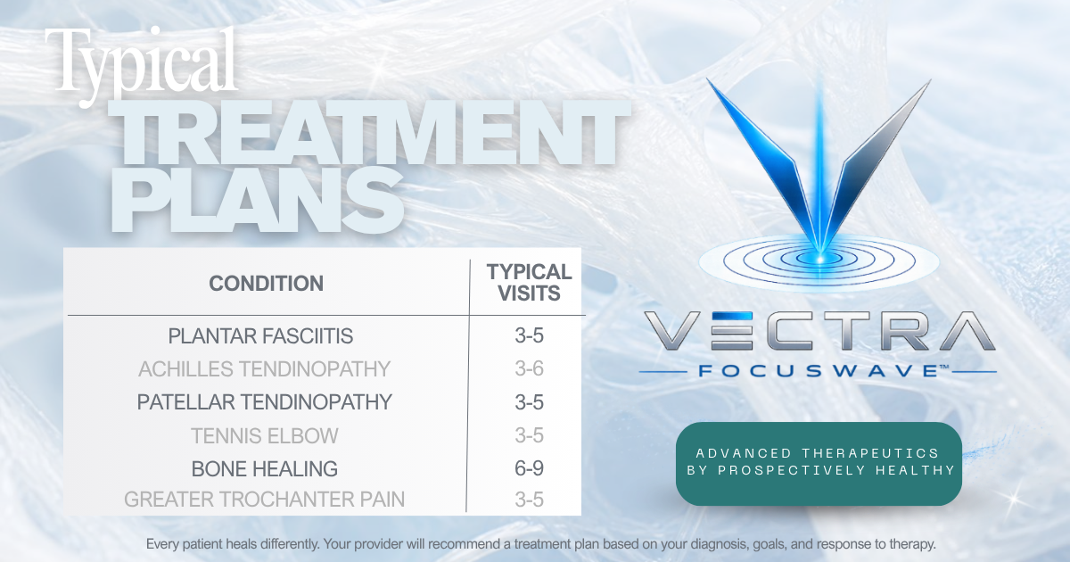
VECTRA™ Focuswave™ may be recommended for a variety of acute and chronic musculoskeletal conditions, particularly those involving tendons, ligaments, fascia, muscles, and certain bone-related injuries. Your provider will determine whether focused shockwave therapy is appropriate based on your diagnosis, medical history, physical examination, and treatment goals.

Common conditions include:

Foot & Ankle
- Plantar fasciitis
- Achilles tendinopathy
- Shin splints (medial tibial stress syndrome)

Knee
- Patellar tendinopathy (Jumper's Knee)
- Quadriceps tendinopathy
- Selected cases of knee osteoarthritis

Hip & Pelvis
- Greater trochanteric pain syndrome
- Gluteal tendinopathy
- Proximal hamstring tendinopathy

Shoulder
- Calcific shoulder tendinitis
- Rotator cuff tendinopathy

Elbow
- Tennis elbow (lateral epicondylitis)
- Golfer's elbow (medial epicondylitis)

Bone & Soft Tissue
- Delayed bone healing (selected patients)
- Certain stress injuries and chronic soft tissue conditions

What Should I Expect?
Unlike treatments that simply mask pain, VECTRA™ Focuswave™ is designed to stimulate your body's natural healing processes. Because healing takes time, improvement is often gradual rather than immediate.

During your treatment plan, you may experience:
- Mild soreness or a temporary increase in symptoms for 24–72 hours following treatment.
- Gradual improvement in pain, mobility, and function over several weeks.
- Noticeable improvement after the first treatment for some patients, while others experience their greatest benefit after completing a series of treatments.
- Continued healing for several weeks after your final treatment as tissue remodeling continues.
For the best possible outcome, it is important to follow your provider's recommendations regarding activity modification, stretching, strengthening, home exercises, and any additional therapies that may be recommended as part of your individualized treatment plan.

Risks & Possible Side Effects
VECTRA™ Focuswave™ is generally well tolerated, and most side effects are mild and temporary.
Common side effects may include:
- Temporary discomfort during treatment
- Mild soreness or tenderness
- Temporary redness
- Mild swelling
- Bruising
- A temporary increase in symptoms for 24–72 hours as the body's healing response begins
Although uncommon, more serious complications have been reported, including prolonged pain, bleeding or hematoma, irritation of nearby nerves, or injury to tissues when treatment is performed over inappropriate areas or with excessive treatment intensity. Your provider will evaluate your medical history and determine whether this treatment is appropriate for you.

Who May Not Be a Candidate?
Focused shockwave therapy may not be appropriate for everyone. Treatment may be delayed, modified, or avoided in certain situations, including:
- Pregnancy
- Active infection in the treatment area
- Known cancer within the planned treatment area
- Active blood clot (deep vein thrombosis)
- Recent corticosteroid injection into the treatment area
- Certain bleeding disorders or use of blood-thinning medications
- Significant loss of protective sensation or severe peripheral neuropathy
- Children or adolescents with open growth plates
- Other medical conditions that, in your provider's clinical judgment, may make treatment inappropriate
Your provider will carefully review your medical history, medications, and current condition to determine whether focused shockwave therapy is a safe and appropriate treatment option for you.

Maximize Your Results
For the best possible outcome, we encourage patients to support their body's natural healing process by:
- Eating a nutrient-dense, protein-rich diet
- Staying well hydrated
- Prioritizing quality sleep and recovery
- Following your prescribed home exercise program
- Using provider-recommended nutritional supplements when appropriate
- Avoiding NSAIDs and ice for 48–72 hours following treatment unless otherwise directed
Your provider may recommend additional nutritional support based on your individual needs and treatment goals.

Pricing
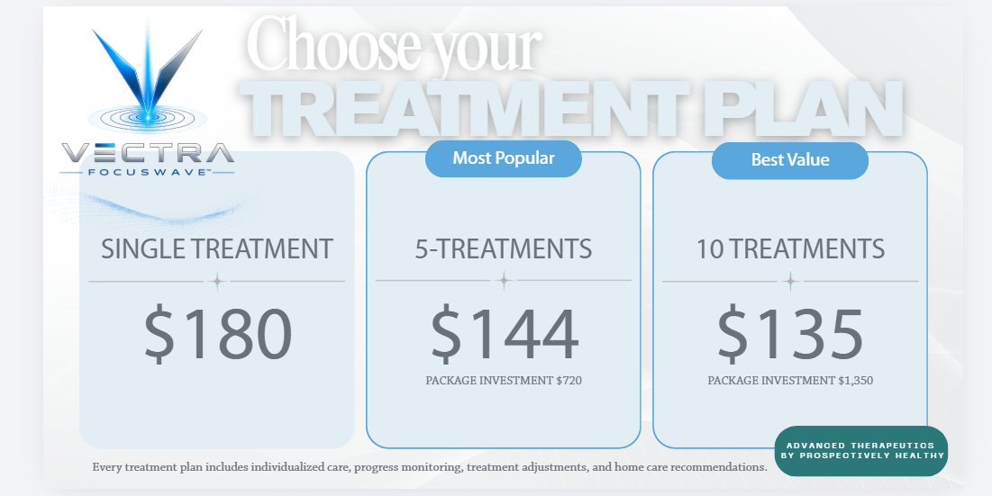
Choose the treatment plan that best fits your recovery goals. Treatment packages provide the greatest value for patients who are committed to achieving lasting results. Patients actively participating in another treatment plan at Prospectively Healthy receive a 15% courtesy discount on individual VECTRA™ treatment sessions. Your provider will help determine the option that best supports your diagnosis, goals, and expected course of care.

Healing Doesn't End Here

Ask your provider about nutrition, movement, supplements, and additional therapies that may complement your VECTRA™ treatment plan.

Frequently Asked Questions

How is VECTRA™ different from other "shockwave" treatments?
VECTRA™ uses true focused shockwave technology, delivering acoustic energy to a precise treatment depth beneath the skin. This allows your provider to target specific injured tissues rather than treating only the surface, making it an excellent option for many tendon, ligament, fascia, muscle, and selected bone conditions.

What is Focused Shockwave Therapy?
VECTRA™ Focuswave™ uses highly focused acoustic waves to stimulate your body's natural healing processes. By promoting circulation, tissue repair, and cellular regeneration, focused shockwave helps reduce pain and improve function without surgery or injections.

What conditions can it treat?
VECTRA™ Focuswave™ is commonly used for conditions such as plantar fasciitis, Achilles tendinopathy, tennis elbow, golfer's elbow, patellar tendinopathy, shoulder pain, hip pain, hamstring injuries, chronic tendon disorders, selected cases of arthritis, and many other musculoskeletal conditions. Your provider will determine if treatment is appropriate for your specific condition.

How long does a treatment take?
Most appointments last 20–30 minutes, which includes evaluation, treatment, and aftercare instructions. The actual VECTRA™ treatment itself typically takes only a few minutes per treatment area.

Does the treatment hurt?
Most patients describe VECTRA™ as a deep tapping or pulsing sensation. Areas with chronic injury or inflammation are often more sensitive than healthy tissue. While some temporary discomfort is expected, treatment is adjusted to maintain a tolerable experience.

Will I feel the treatment deep inside the tissue?
Yes. Unlike more superficial therapies, focused shockwave is designed to target tissues beneath the skin. Many patients describe the sensation as originating deep within the injured area rather than at the surface.

Why do you use ultrasound gel?
A small amount of coupling gel is applied to help transfer the acoustic energy efficiently from the treatment applicator into the targeted tissue. The gel is not a medication and simply improves energy transmission.

Does the handpiece move during treatment?
Not continuously. Your provider carefully identifies the injured tissue and maintains precise contact over the treatment area, making only small adjustments as needed to treat additional structures.

Can I purchase a single treatment?
Absolutely. Individual treatments are available for patients who wish to try VECTRA ™ or require only occasional care.

Do I have to purchase a package?
No. Packages are optional but provide the best overall value for patients who are expected to benefit from multiple treatments.

I’m already a patient. Do I receive a discount?
Yes! Patients actively participating in another treatment plan at Prospectively Healthy receive 15% off individual VECTRA ™ treatment sessions.

Can I use my HSA or FSA?
In many cases, yes. We recommend checking with your HSA/FSA administrator to confirm your specific plan’s eligibility requirements.

What should I expect afterward?
It’s common to experience mild soreness or a temporary increase in symptoms for 24-72 hours as your body’s natural healing response begins. Most patients gradually notice improvements in pain, function, and mobility over the course of their treatment plan.

How many treatments will I need?
Treatment recommendations vary depending on your diagnosis, symptom duration, and treatment goals. Most patients benefit from 3–6 treatments, typically scheduled about one week apart, although some conditions may require additional visits. Your provider will recommend an individualized treatment plan.

Will I feel better immediately?
Some patients notice improvement after their first treatment, while others experience more gradual progress. Most healing occurs over 4–12 weeks as your body responds to treatment and damaged tissues continue to remodel.

Can I exercise afterward?
In most cases, yes. Your provider may recommend temporarily modifying high-impact activities or strenuous exercise depending on your condition and stage of healing. Walking and normal daily activities are typically encouraged unless otherwise directed.

Can I combine VECTRA™ with other services at Prospectively Healthy?
Absolutely. VECTRA™ Focuswave™ is often paired with other therapies to support healing and improve outcomes. Depending on your diagnosis and treatment goals, your provider may recommend combining treatment with chiropractic care, regenerative medicine, rehabilitation exercises, nutritional support, or other therapies offered at Prospectively Healthy.
For the best clinical response, thermotherapy and Class IV laser treatments should be performed after your VECTRA™ session, as recommended by your provider.

We're here to help. If you have additional questions about VECTRA™ Focuswave™, your treatment plan, or whether focused shockwave therapy is right for you, please contact our office. Our team is happy to help guide you through the next steps of your recovery.

